Title of communication
S. Name¹, L. Name ^{2,}*… C. NAME³
¹ Affiliation
² Affiliation
³ Affiliation
*email corresponding author
Summary will not exceed 2 pages length including figures and references

Keywords : (maximum 5) Time new roman, 12, bold

Section 1 (Time new roman, 12, bold)

Sub section (Time new roman, 11, Italic)

The whole document will be written in Times New Roman, font size 11.
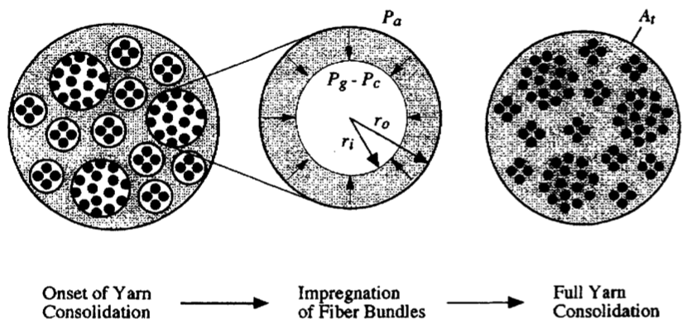
Fig. 1 – Schematic of a representative yarn cross-section and the assumed consolidation process [1]

Images/figures will be centered in the page (Style « Illustrations ») followed by caption (fonts 11 in italic).

Sub- section2 (Time new roman, 11, Italic)

Conclusions

References (Times New Roman, font 11)

[1] A. Laporte, I. Faifroid, H. Tague, T. Alamente Polymer loukoums and Cornes de gazelles, 2012, Vol 97 (10), 1915-1921.
[2] R. Derien, P. Peboington, A. Laqueuleuleu. “Injection des polymères, simulation optimisation et conception”, Editions Lavoisier, 2002.
[3] J. Doe, J. Doe. submitted to name of journal, 2013.
[4] J. Doe, J. Doe. brevet FR 0,000,000, 000. 2013

